Use Case Realisation Report (Analysis) - Manage Itinerary
FOR
Volunteer Management System
(VMS)

CLIENT
PROJECT | Volunteer Management System (VMS)
TITLE | Use Case Realisation Report (Analysis) - Manage Itinerary
VERSION | 0.1a
DATE | 13-Aug-2011
 | ORIGINATOR
 | Name / Signature | Team 8S
 | APPROVAL
 | Name / Signature | Phung Kim Cuong, Dio
Institute of Systems Science |  | Document Reference
25 Heng Mui Keng Terrence  Singapore 119615 |  | VMS/T-1.4.1/1

 | Acceptance
 | Customer Signature |  | Customer Signature
 | Name & Designation |  | Name & Designation
 | Date & Company Stamp |  | Date & Company Stamp

Revision History

Date | Version | Description | Author
12-Jun-2011 | 0.1a | Creation | Team 8S
 |  | Refer to amendment history

Table of Contents

1. Brief Description 3
2. Flow of Events 3
2.1 Standard Flow 3
2.1.1 List Itinerary 3
2.1.2 View Itinerary 3
2.1.3 Create Itinerary 4
2.1.4 Update Itinerary 4
2.1.5 Delete Itinerary 5
2.1.6 Submit Itinerary 5
2.1.7 Review Itinerary 5
2.2 Exceptions 6
3. Interaction Diagrams 7
3.1 Collaboration Diagram for List Itinerary 7
3.2 Collaboration Diagram for View Itinerary 7
3.3 Collaboration Diagram for Create Itinerary 8
3.4 Collaboration Diagram for Update Itinerary 8
3.5 Collaboration Diagram for Delete Task 9
4. Participating Objects 9
4.1 User 9
This entity object stores the details concerning a user of the volunteer organisation. The primary attribute that it holds is the userID. 9
4.2 Project Manager 9
4.3 Date 9
4.4 Task 10
4.5 Project 10
4.6 ItineraryListingScreen 10
4.7 CreateItineraryScreen 10
4.8 UpdateItineraryScreen 10
4.9 ViewItineraryScreen 10
4.10 HomeScreen 10
4.11 MainController 10
4.12 ItineraryController 10
5. Class Diagrams 11
6. Derived Requirements 11
ANNEX D Amendment History 12

Use Case Realisation Report (Analysis) - Manage Itinerary

Brief Description
The use case enables a User to view a calendar of events based on month.

Flow of Events
The standard flow of events for this use case and any exceptions are described in the following subsections. See section 3.1 for an overview of the participating Actors and Domain Objects.

Standard Flow
Precondition: User has logged in the system.
This use case provides the user interface related functionality that will be provided to the Project Manager for interaction with regards to itinerary management, as follows:

List Itinerary
- The use case starts when the User selects the calendar option from the HomeScreen. The HomeScreen.getIntineraryMenu() operation is triggered.
- The getCalendarMenu() operation triggers the MainController.getIntineraryMenu() which delegates to the ItineraryController.getTaskList() operation.
- Using the userID and date, the ItineraryController.getItineraryList() operation triggers Task.getTaskList() operation to retrieve the task records using the userID. The ItineraryController.getItineraryList() operation triggers also triggers the Project.getProject() operation to retrieve the project records based on the projectID that is related to the itineraries.
- The ItineraryController triggers the ItineraryListingScreen.show() operation to display the list of projects by triggering the Task.getTaskList() operation and the Project.getName() operation.
- The use case terminates.

View Itinerary
- The use case starts when the User selects a record to view from the ItineraryListingScreen. The ItineraryListingScreen.getItinerary() operation is triggered.
- Using the taskID, the ItineraryController.getItinerary() operation triggers Task.getTask() operation to retrieve the task details based on the taskID and the Project.getProject() operation is triggered to retrieve the project name for this itinerary.
- The ItineraryController triggers the ViewItineraryScreen.show() operation to display the ViewItineraryScreen by triggering the Task.getAttribute() operation to retrieve the event details and Project.getName() to retrieve the project name.
- The use case terminates.

Create Itinerary
- The use case starts when the Project Manager selects the create event option from the ItineraryListingScreen. The ItineraryListingScreen.getViewCreate() operation is triggered.
- The ItineraryController triggers the CreateItineraryScreen.show() operation to display the CreateItineraryScreen.
- The User enters the task details of the new itinerary into the text fields of CreateItineraryScreen.
- When the User selects the Create button in the form, the CreateItineraryScreen.validate() operation performs form validation based on the input fields.
- Upon successful validation, CreateItineraryScreen.createItinerary() operation triggers the ItineraryController.createItinerary() operation and provides the Task object by triggering the Task.getTask() and Project.getProject() operation to retrieve the project object to get the project ID to create a task. The createTask() operation assigns a new task ID by using the operation Task.getNextTaskID() operation.
- The ItineraryController.createItinerary() operation sets the date of created date of the event which the date is retrieved via the Date.getDate().
- The ItineraryController triggers Task.createTask() operation to create the new Task object details including order number, name, description, duration and status. The system displays an informational message for successfully updated message in the ItineraryListingScreen by triggering the ItineraryListingScreen.showMessage() operation.
- The use case terminates.

Update Itinerary
- The use case starts when the User selects a record to update from the ItineraryListingScreen. The ItineraryListingScreen.getViewUpdate() operation is triggered.
- The ItineraryController.getViewUpdate() operation triggers Task.getTask() operation to retrieve the task details and the Project.getProject() operation is triggered to retrieve the project details related to the task.
- The ItineraryController triggers the ViewItineraryScreen.show() operation to display the UpdateItineraryScreen by triggering the Task.getAttribute() operation and Project.getAttribute() to display the details.
- The User selects the Update button to update the updates the project details of the project into the text fields of UpdateItineraryScreen.
- When the User selects the Update button in the form, the UpdateItineraryScreen.validate() operation performs form validation based on the input fields.
- Upon successful validation, UpdateItineraryScreen.updateItinerary() operation triggers the ItineraryController.updateItinerary() operation and provides the Task object to update the task of the itinerary.
- The ItineraryController triggers Task.updateTask() operation to update the new Task object details ncluding order number, name, description, duration and status. The system displays an informational message for successfully updated message in the ItineraryListingScreen by triggering the ItineraryListingScreen.showMessage() operation
- The use case terminates.

Delete Itinerary
- The use case starts when the Project Manager selects the update project option from the ItineraryListingScreen. The update option is performed by the Update Itinerary use case.
- The Project Manager selects the checkbox for the record(s) that is to be deleted and select Delete button to delete the task. The Update The flow is the same as the Update Itinerary use case with the status updated as Submitted.
- The UpdateItineraryScreen.deleteItinerary() operation triggers the ItineraryController.deleteItinerary() operation and provides the Task object to delete the task(s) of the itinerary.
- The system displays an informational message for successfully deletion in the UpdateItineraryScreen by triggering the UpdateItineraryScreen.showMessage() operation
- The use case terminates.

Submit Itinerary
- The use case starts when the Project Manager selects the update project option from the ItineraryListingScreen. The update option is performed by the Update Itinerary use case.
- The Project Manager selects the Submit button to submit the itinerary to the Project Coordinator for approval. The flow is the same as the Update Itinerary use case with the status updated as Submitted.
- The use case terminates.

Review Itinerary
- The use case starts when the Project Coordinator selects the update project option from the ItineraryListingScreen. The update option is performed by the Update Itinerary use case. However, the Project Coordinator can only view the itinerary and to approve or reject the itinerary.
- The Project Manager selects the Approve or Reject button to submit the itinerary to the Project Coordinator for approval. The flow is the same as the Update Itinerary use case with the status updated as Approved or Rejected (depending on the button selected).
- The use case terminates.

Exceptions
The following exceptions were identified:
- Validation fails. If the CreateItineraryScreen.validate() operation fails, the project creation fails. An error message is displayed in the CreateItineraryScreen by triggering the operation CreateItineraryScreen.showMessage().
- Validation fails. If the UpdateItineraryScreen.validate() operation fails, the project creation fails. An error message is displayed in the UpdateItineraryScreen by triggering the operation UpdateItineraryScreen.showMessage().

Interaction Diagrams

Collaboration Diagram for List Itinerary
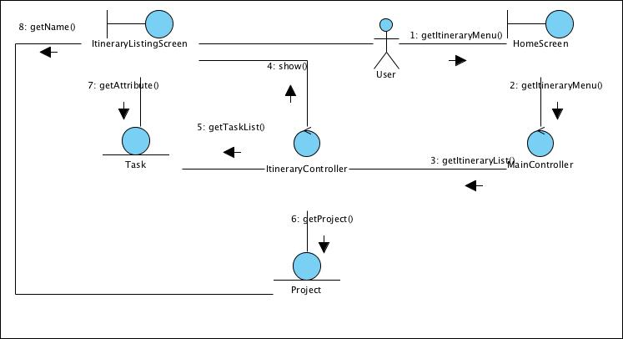
Figure 1 – Collaboration Diagram for List Itinerary

Collaboration Diagram for View Itinerary
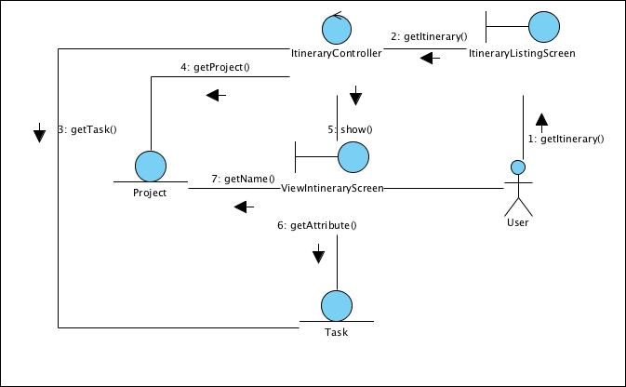
Figure 2 – Collaboration Diagram for View Itinerary

Collaboration Diagram for Create Itinerary
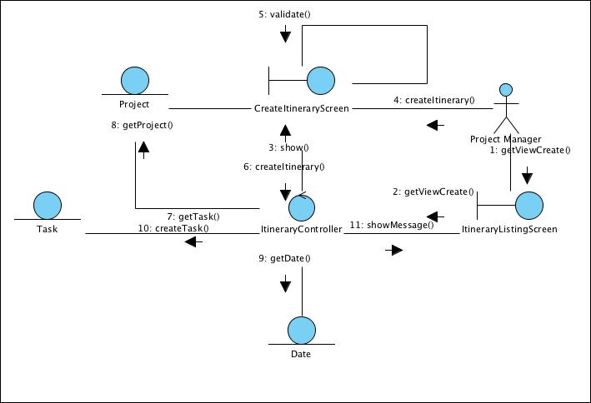
Figure 3 – Collaboration Diagram for Create Itinerary

Collaboration Diagram for Update Itinerary
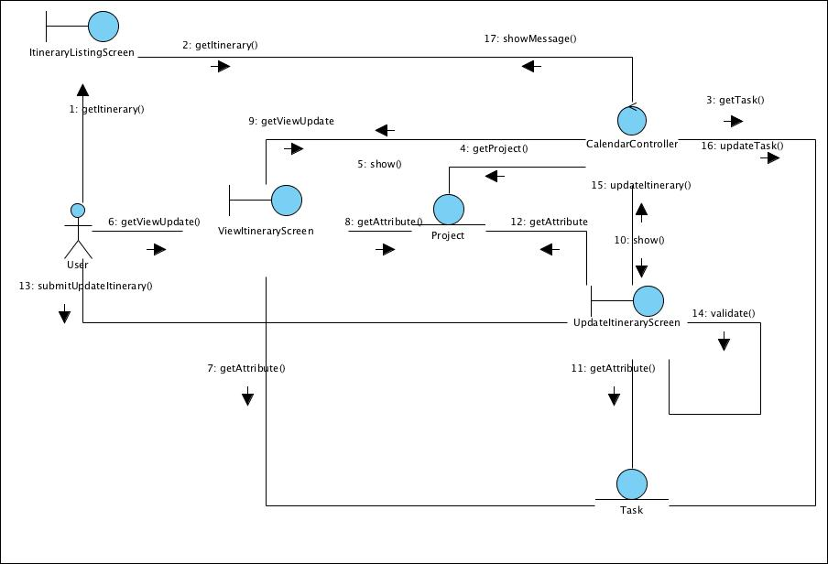
Figure 4 – Collaboration Diagram for Update Itinerary

Collaboration Diagram for Delete Task
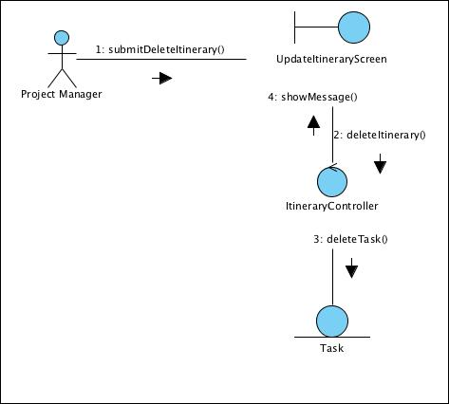
Figure 5 – Collaboration Diagram for Delete Task

Participating Objects

User

This entity object stores the details concerning a user of the volunteer organisation. The primary attribute that it holds is the userID.

Project Manager
This is a Staff object type with a project manager role as an attribute.

Date
This entity object stores the current date.

Task
This entity object stores the details concerning a task of a project’s itinerary. The primary attribute that it holds is the projectID.

Project
This entity object stores the details concerning a task of the volunteer organisation. The primary attribute that it holds is the taskID.

ItineraryListingScreen
This boundary object is used for collection of task listing details. User actor uses this object.

CreateItineraryScreen
This boundary object is used for collection of task details, which a new task record is to be created for the itinerary. The User actor uses this object.

UpdateItineraryScreen
This boundary object is used for collection of task details, which an event record is to be updated. The User actor uses this object.

ViewItineraryScreen
This boundary object is used for collection of task details, which an event record is to be viewed. The User actor uses this object.

HomeScreen
This boundary object is used for redirecting and displaying of home screen details and menu. All the user actors use this object.

MainController
This control object co-ordinates the menu selection and dispatches of requests of the volunteer management system. It delegates the user requests to the specific use case control objects for carrying out the use cases.

ItineraryController
This control object co-ordinates the creation, update and viewing itinerary task record in the volunteer management system. It receives requests from the boundary objects allocated for the specific purposes, along with all the necessary details required for the execution of these requests.

Class Diagrams

Derived Requirements
The Staff office PC (client system), keyboard and mouse will be used to process the project details and view all the system responses.

ANNEX D Amendment History

This is a record of all amendments made to the Document.
Version | Chapter / Section | Page No | Notes of Amendments or Changes

